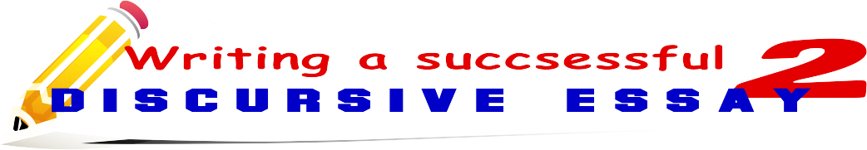

SET 1- REMEMBERING

- looking back
- with hindsight/in hindsight/ in retrospect
- when I look back
- I can recall
- As far as I can recall
- I have a vague recollection of
- I will never forget
- It was a lifetime experience for me when
SET 2- COMPARISION

- in other words
- just as
- as well as
- both... and
- compared to
- in comparison with
- in the same way
- neither... nor
- similarly/ likewise
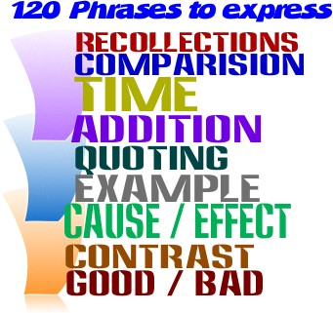

SET 5 -QUOTING
- According to
- Let me quote ..
- As (a wise man) said
- He notes . . .
- He concludes
- He mentions
- He observes
- He comments
- He reports
- He claims
- He expresses
- He suggests
- He confirms
- He dismisses
- He argues
- He admits
- He acknowledges
- He points out
- He views
- He shares his opinion about
- He emphasizes
- He reveals
- He declares
- He accounts on
SET 4- ADDITION

- also
- additionally/ in addition
- besides
- moreover/ what is more
- furthermore
- last but not least
- not only... but also
SET 7 - CAUSE-EFFECT

- then
- therefore
- as a result/ as a consequence/
- consequently
- for this reason
- thus/ hence
- accordingly
- owing to
- because
- because of
- owing to
- thanks to
- since/ for/ as
SET 3- TIME

- after a while
- afterwards
- at the same time
- previously
- at last
- currently/ at present/ presently
- earlier
- eventually
- finally
- formerly
- immediately / at once
- in the meantime
- later
- simultaneously
- subsequently
SET 8 - CONTRAST

- however
- instead
- nevertheless
- nonetheless
- on the one hand
- on the other hand
- in contrast to
- on the contrary
- otherwise
- still

SET 6 - EXAMPLE

- for example
- for instance
- in other words
- to paraphrase
- as an example
- as an illustration
- to exemplify
SET 10– AVOIDING SAYING “BAD”
110. awful 116. atrocious
111. disgusting 117. despicable
112. dreadful 118. detestable
113. ghastly 119. evil
114. horrible 120. unpleasant
115. terrible

SET 9 – AVOIDING SAYING “GOOD”
94. excellent 102. marvelous
95. wonderful 103. perfect
96. brilliant 104. enjoyable
97. superb 105. pleasant
98. amazing 106. great
99. terrific 107. outstanding
100. awesome 108. attractive
101. splendid 109. admirable

Writing a successful essay - 2

SET 1- REMEMBERING

- looking back
- with hindsight/in hindsight/ in retrospect
- when I look back
- I can recall
- As far as I can recall
- I have a vague recollection of
- I will never forget
- It was a lifetime experience for me when
SET 2- COMPARISION

- in other words
- just as
- as well as
- both... and
- compared to
- in comparison with
- in the same way
- neither... nor
- similarly/ likewise
120 phrases to express
- recollections
- comparison
- time
- addition
- quoting
- example
- cause/ effect
- contrast
- good / bad

SET 5 -QUOTING/ SAYING “SAY”
- According to
- Let me quote ..
- As (a wise man) said
- He notes . . .
- He concludes
- He mentions
- He observes
- He comments
- He reports
- He claims
- He expresses
- He suggests
- He confirms
- He dismisses
- He argues
- He admits
- He acknowledges
- He points out
- He views
- He shares his opinion about
- He emphasizes
- He reveals
- He declares
- He accounts on
SET 4- ADDITION

- also
- additionally/ in addition
- besides
- moreover/ what is more
- furthermore
- last but not least
- not only... but also
SET 7 - CAUSE-EFFECT

- then
- therefore
- as a result/ as a consequence/
- consequently
- for this reason
- thus/ hence
- accordingly
- owing to
- because
- because of
- owing to
- thanks to
- since/ for/ as
SET 3- TIME

- after a while
- afterwards
- at the same time
- previously
- at last
- currently/ at present/ presently
- earlier
- eventually
- finally
- formerly
- immediately / at once
- in the meantime
- later
- simultaneously
- subsequently
SET 6 - EXAMPLE

- for example
- for instance
- in other words
- to paraphrase
- as an example
- as an illustration
- to exemplify
SET 8 - CONTRAST

- however
- instead
- nevertheless
- nonetheless
- on the one hand
- on the other hand
- in contrast to
- on the contrary
- otherwise
- still

SET 10– AVOIDING SAYING “BAD”
110. awful 116. atrocious
111. disgusting 117. despicable
112. dreadful 118. detestable
113. ghastly 119. evil
114. horrible 120. unpleasant
115. terrible

SET 9 – AVOIDING SAYING “GOOD”
94. excellent 102. marvelous
95. wonderful 103. perfect
96. brilliant 104. enjoyable
97. superb 105. pleasant
98. amazing 106. great
99. terrific 107. outstanding
100. awesome 108. attractive
101. splendid 109. admirable

