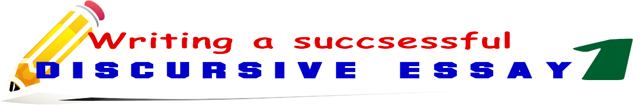

**SET 2 - Obvious facts**

1. I am quite sure
2. I am absolutely sure
3. I am quite sure
4. It is clear
5. It is obvious
6. It cannot be argued that
7. It goes without saying that
8. There is no doubt that
9. Evidence suggests that
10. It is generally accepted that
11. It’s a well-known fact that
12. Needless to say,
13. I am convinced that
14. I am deeply convinced
15. It’s very likely / it’s highly likely
16. No one can deny that
17. no matter what they say
18. surely / definitely / of course / certainly
19. I know it from my experience that
20. everybody agrees that

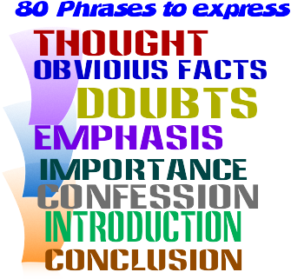

**SET 1 – Saying ”I think”**

1. I believe
2. I consider
3. I feel
4. I suppose
5. I assume
6. I presume
7. In my opinion
8. To my mind
9. It seems to me
10. It appears to me
11. As far as I'm concerned
12. In my point of view
13. From my perspective
14. Generally speaking,

**SET 3 - Feeling doubtful**

1. I doubt that
2. It’s hard to say that
3. It’s a controversial issue
4. I’m not sure
5. It’s very unlikely / it’s highly unlikely
6. No one can know for certain
7. I find it difficult to believe
8. It seems suspicious
9. it is hard to say for certain, that
10. it is hard to prove, that

**SET 4-Emphasizing /drawing attention**

1. I’d like to emphasize
2. I’d like to draw your attention to the fact that that
3. I’d like to stress the importance of (the fact that)
4. I’d like to point out that
5. I´d like to highlight the importance of (the fact that)
6. We should keep in mind that
7. Let us not forget that

**SET 5 - Stating the importance**

1. It is vital
2. It is crucial
3. It is vitally important
4. It is essential
5. It is utterly important

**SET 8 - Summarizing**

1. To sum up,
2. To summarize,
3. In summary,
4. In conclusion,
5. To conclude with,
6. In short,
7. In brief,
8. To put it in a nutshell,
9. Finally,
10. Lastly,
11. All things considered,
12. On the whole

**SET6- Admitting/ being frank**

1. To be honest
2. To be frank with you,
3. Frankly speaking,
4. Honestly,
5. Admittedly,
6. I must admit that,

**SET 7 - Beginning**

1. To begin with,
2. First of all,
3. First and foremost,
4. Above all,
5. In the first place
6. Initially,

Writing a successful discursive essay - 1

**8o phrases to express**

* **opinion**
* **obvious facts**
* **doubts**
* **emphasis**
* **importance**
* **confession**
* **introduction**
* **conclusion**

**SET 2 - Obvious facts**

1. I am quite sure
2. I am absolutely sure
3. I am quite sure
4. It is clear
5. It is obvious
6. It cannot be argued that
7. It goes without saying that
8. There is no doubt that
9. Evidence suggests that
10. It is generally accepted that
11. It’s a well-known fact that
12. Needless to say,
13. I am convinced that
14. I am deeply convinced
15. It’s very likely / it’s highly likely
16. No one can deny that
17. no matter what they say
18. surely / definitely / of course / certainly
19. I know it from my experience that
20. everybody agrees that

**SET 1 – Saying ”I think”**

1. I believe
2. I consider
3. I feel
4. I suppose
5. I assume
6. I presume
7. In my opinion
8. To my mind
9. It seems to me
10. It appears to me
11. As far as I'm concerned
12. In my point of view
13. From my perspective
14. Generally speaking,

**SET 3 - Feeling doubtful**

1. I doubt that
2. It’s hard to say that
3. It’s a controversial issue
4. I’m not sure
5. It’s very unlikely / it’s highly unlikely
6. No one can know for certain
7. I find it difficult to believe
8. It seems suspicious
9. it is hard to say for certain, that
10. it is hard to prove, that

**SET 4-Emphasizing / drawing attention**

1. I’d like to emphasize
2. I’d like to draw your attention to the fact that that
3. I’d like to stress the importance of (the fact that)
4. I’d like to point out that
5. I´d like to highlight the importance of (the fact that)
6. We should keep in mind that
7. Let us not forget that

**SET 8 - Summarizing**

1. To sum up,
2. To summarize,
3. In summary,
4. In conclusion,
5. To conclude with,
6. In short,
7. In brief,
8. To put it in a nutshell,
9. Finally,
10. Lastly,
11. All things considered,
12. On the whole

**SET 5 - Stating the importance**

1. It is vital
2. It is crucial
3. It is vitally important
4. It is essential
5. It is utterly important

**SET6- Admitting/ being frank**

1. To be honest
2. To be frank with you,
3. Frankly speaking,
4. Honestly,
5. Admittedly,
6. I must admit that,

**SET 7 - Beginning**

1. To begin with,
2. First of all,
3. First and foremost,
4. Above all,
5. In the first place
6. Initially,

**SET6- Admitting/ being frank**

1. To be honest
2. To be frank with you,
3. Frankly speaking,
4. Honestly,
5. Admittedly,
6. I must admit that,