expresses true or very probable situation in the present or future.

If + **Present Simple**, **Future Simple**

**Imperative**

**can/may/might/**

**must/should**

**+ bare infinitive**

If it **is** sunny, we **will go** to the beach.

If you **need** help, **ask** me.

If you **do** your homework, you **can go** out.

If you **go** hiking, you **must wear** hiking boots.

expresses untrue or improbable situations in the present or future.

If + **Past Simple**, **would/could/**

**might**

**+ bare infinitive**

If I **had** more free time, I **would take up** gardening.

If I **won** a lot of money in a lottery, I **might give** some to charity.

expresses unreal, impossible situations in the past.

If + **Past Perfect**, **would have**

**+ past participle**

If I **had seen** Robert, I **would have talked** to him.

1. If Dave _ _ _ _ _ _ _ _ _ _ (not, invite) me to his birthday party, I would feel disappointed.
2. If I hadn’t got up earlier, I _ _ _ _ _ _ _ _ _ _ (miss) my flight to Vienna.
3. We _ _ _ _ _ _ _ _ _ _ (stay) at home if it snows tomorrow.
4. If we _ _ _ _ _ _ _ _ _ _ (earn) enough money, we’ll buy a new hi-fi system.
5. What would you do if you _ _ _ _ _ _ _ _ _ _ (get) lost in a forest at night?
6. Kevin wouldn’t have moved to Britain if he _ _ _ _ _ _ _ _ _ _ (find) a decent job here.
7. If I knew Diana’s address, I _ _ _ _ _ _ _ _ _ _ (send) her a valentine card.
8. What _ _ _ _ _ _ _ _ _ _ (Jane, do) if she fails the university entrance examination?
9. If John’s parents _ _ _ _ _ _ _ _ _ (know) French, they could help him with his project.

10. If Finn _ _ _ _ _ _ _ _ _ _ (apologize) to me, I would

have forgiven him.

11. My cousin would play video games all day long if his

parents _ _ _ _ _ _ _ _ _ _ (allow) him to.

12. If Emma _ _ _ _ _ _ _ _ _ _ (not, feel) better

tomorrow, she should see a doctor.

13. Who _ _ _ _ _ _ _ _ _ _ (you, choose) if you could take

one friend to go to Disneyland with you?

14. Kate _ _ _ _ _ _ _ _ _ (call) you if she had known you

were ill.

15. If you _ _ _ _ _ _ _ _ _ _ (be) cold, you can put on

warm socks and a bathrobe.

16. James would buy his wife a BMW if he _ _ _ _ _ _ _ _ _

(be) richer.

17. If Barbara and Paul _ _ _ _ _ _ _ _ _ _ (spend) more

time together their marriage would have lasted

longer.

18. My parents _ _ _ _ _ _ _ _ _ _ (buy) me a new MP3

player if I pass my final exams.

19. If my team _ _ _ _ _ _ _ _ _ _ (lose) the match, we will

fall to the second division.

20. If the concert _ _ _ _ _ _ _ _ _ _ (finish) earlier, I

would have taken the 10.30 bus.

**Complete the sentences with the correct form of the verbs.**

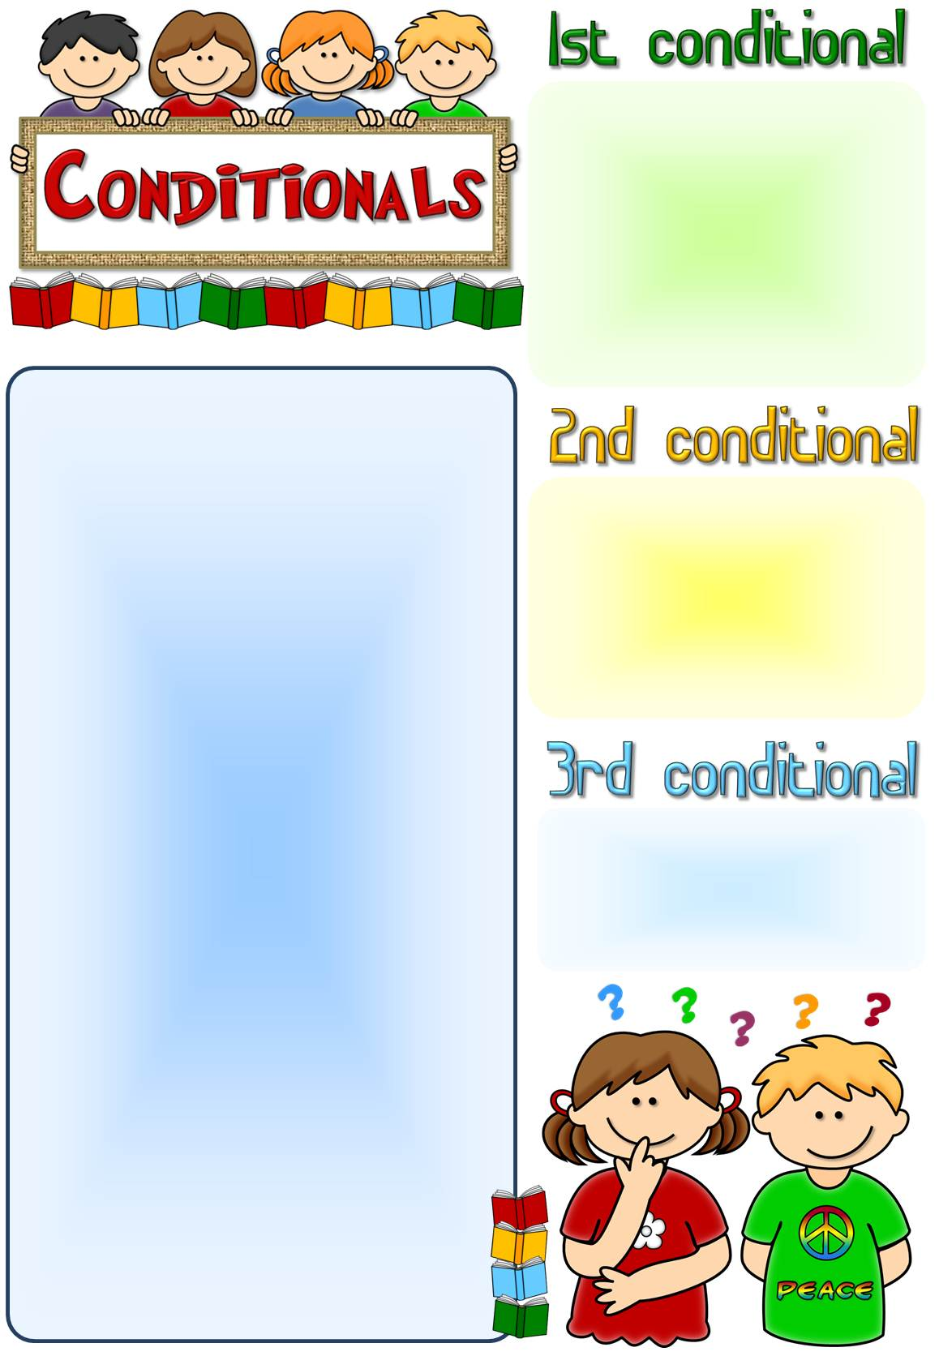

expresses true or very probable situation in the present or future.

If + **Present Simple**, **Future Simple**

**Imperative**

**can/may/might/**

**must/should**

**+ bare infinitive**

If it **is** sunny, we **will go** to the beach.

If you **need** help, **ask** me.

If you **do** your homework, you **can go** out.

If you **go** hiking, you **must wear** hiking boots.

expresses untrue or improbable situations in the present or future.

If + **Past Simple**, **would/could/**

**might**

**+ bare infinitive**

If I **had** more free time, I **would take up** gardening.

If I **won** a lot of money in a lottery, I **might give** some to charity.

expresses unreal, impossible situations in the past.

If + **Past Perfect**, **would have**

**+ past participle**

If I **had seen** Robert, I **would have talked** to him.

1. If Dave _ _ _ _ _ _ _ _ _ _ (not, invite) me to his birthday party, I would feel disappointed.
2. If I hadn’t got up earlier, I _ _ _ _ _ _ _ _ _ _ (miss) my flight to Vienna.
3. We _ _ _ _ _ _ _ _ _ _ (stay) at home if it snows tomorrow.
4. If we _ _ _ _ _ _ _ _ _ _ (earn) enough money, we’ll buy a new hi-fi system.
5. What would you do if you _ _ _ _ _ _ _ _ _ _ (get) lost in a forest at night?
6. Kevin wouldn’t have moved to Britain if he _ _ _ _ _ _ _ _ _ _ (find) a decent job here.
7. If I knew Diana’s address, I _ _ _ _ _ _ _ _ _ _ (send) her a valentine card.
8. What _ _ _ _ _ _ _ _ _ _ (Jane, do) if she fails the university entrance examination?
9. If John’s parents _ _ _ _ _ _ _ _ _ (know) French, they could help him with his project.

10. If Finn _ _ _ _ _ _ _ _ _ _ (apologize) to me, I would

have forgiven him.

11. My cousin would play video games all day long if his

parents _ _ _ _ _ _ _ _ _ _ (allow) him to.

12. If Emma _ _ _ _ _ _ _ _ _ _ (not, feel) better

tomorrow, she should see a doctor.

13. Who _ _ _ _ _ _ _ _ _ _ (you, choose) if you could take

one friend to go to Disneyland with you?

14. Kate _ _ _ _ _ _ _ _ _ (call) you if she had known you

were ill.

15. If you _ _ _ _ _ _ _ _ _ _ (be) cold, you can put on

warm socks and a bathrobe.

16. James would buy his wife a BMW if he _ _ _ _ _ _ _ _ _

(be) richer.

17. If Barbara and Paul _ _ _ _ _ _ _ _ _ _ (spend) more

time together their marriage would have lasted

longer.

18. My parents _ _ _ _ _ _ _ _ _ _ (buy) me a new MP3

player if I pass my final exams.

19. If my team _ _ _ _ _ _ _ _ _ _ (lose) the match, we will

fall to the second division.

20. If the concert _ _ _ _ _ _ _ _ _ _ (finish) earlier, I

would have taken the 10.30 bus.

**Complete the sentences with the correct form of the verbs.**



1. If Dave **didn’t invite** me to his birthday party, I would feel disappointed.
2. If I hadn’t got up earlier, I **would have missed** my flight to Vienna.
3. We **will stay** at home if it snows tomorrow.
4. If we **earn** enough money, we’ll buy a new hi-fi system.
5. What would you do if you **got**) lost in a forest at night?
6. Kevin wouldn’t have moved to Britain if he **had found** a decent job here.
7. If I knew Diana’s address, I **would send** her a valentine card.
8. What **will Jane do** if she fails the university entrance examination?
9. If John’s parents **knew** French, they could help him with his project.

10. If Finn **had apologized** to me, I would have forgiven him.

11. My cousin would play video games all day long if his parents **allowed** him to.

12. If Emma **doesn’t feel** better tomorrow, she should see a doctor.

13. Who **would you choose**  if you could take one friend to go to Disneyland with you?

14. Kate **would have called** you if she had known you were ill.

15. If you **are** cold, you can put on warm socks and a bathrobe.

16. James would buy his wife a BMW if he **were/was** richer.

17. If Barbara and Paul **had spent** more time together their marriage would have lasted longer.

18. My parents **will buy** me a new MP3 player if I pass my final exams.

19. If my team **loses** the match, we will fall to the second division.

20. If the concert **had finished** earlier, I would have taken the 10.30 bus.

**Complete the sentences with the correct form of the verbs.**